Practical 13
- Write a recursive method void reverse() that reverse a sentence. For example:

Sentence greeting = new Sentence(“Hello!”);
greeting.reverse();
System.out.println(greeting.getText());

Prints the string “!olleh”. Implement a recursive solution by removing the first character, reversing a sentence consisting of the remaining text, and combining the two.

- Use recursion to implement a method boolean find(String t) that tests whether a string is contained in a sentence:

Sentence s = new Sentence(“Mississippi”);
boolean b=s.find(“sip”);

Hints: If the text starts with the string you want to match, then you are done. If not, consider the sentence that you obtain by removing the first character.

- Write a simple Moving clock application. This application should create a frame size of (500,500). This application should display the system time in the frame created. The location to display the clock should follow the mouse cursor. You should use Timer class in this question to allow time to update in every second. The clock should appear in RED color. You should set the font size to 45. The background color should be set to GREEN. You should implement MouseMotionListener interface. The diagrams below show the sample output.

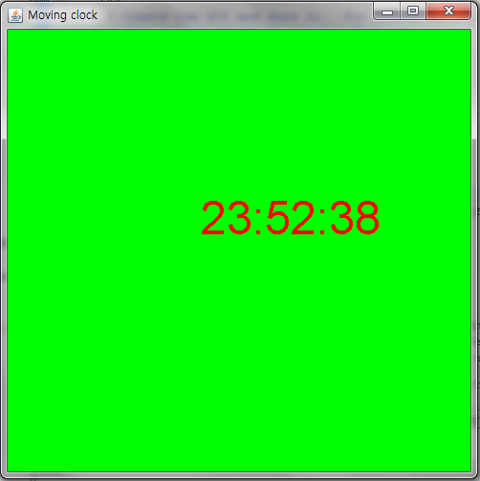
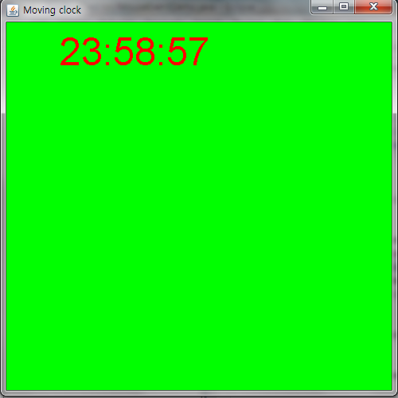

- Write a simple Random Text Generator. This application should create a frame size of (500,500). This program should start with asking user a message and create a message in the frame in Random Size, Random Color, and Random Position. You should use Timer class in this question to allow time to update in every second. The background color should be set to BLACK. The diagrams below show the sample output.

Output1 --- Asking user for the message in console
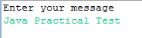

Output 2 ---- Showing the message in random color, random position, random size.
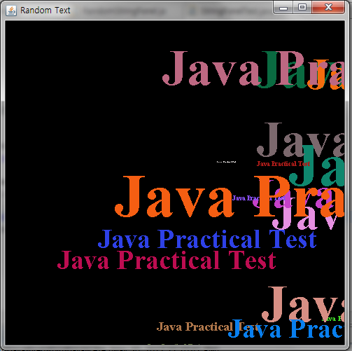

- Deﬁne a new exception, called ExceptionLineTooLong, that prints out the error message "The strings is too long". Write a program that reads all lines of a ﬁle and throws an exception of type ExceptionLineTooLong in the case where a string of the ﬁle is longer than 80 characters. Handle also all exceptions that could be thrown by the program.

